**Developer terms**

**Display requirements: Replies**

**Replies**

Please follow the following guidelines for displaying replies.

For a default reply:

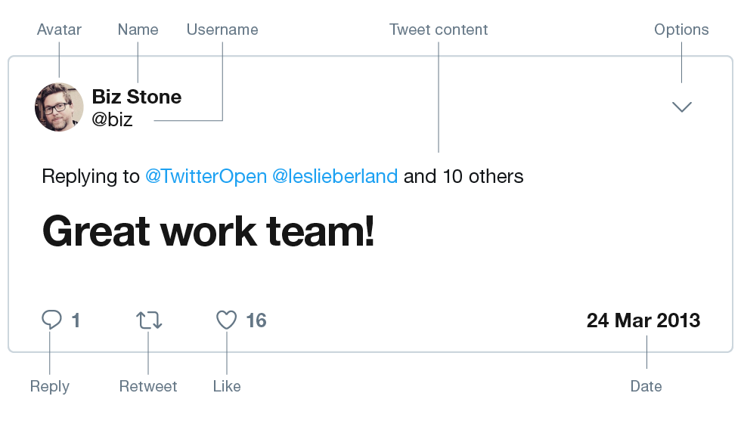

For a reply with social context:

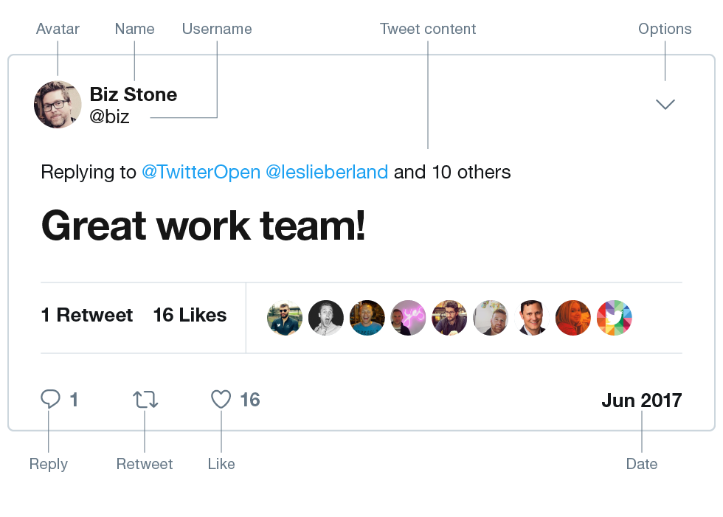

For a Quote Tweet:

